**Lab 7**

**Name:** Etcherla Sai Manoj **Mis. No:** 112015044 **Branch:** CSE

**Question1:**

**Code:**

#include<iostream>

#include<cstring>

using namespace std;

class Amazon_music{

public:

string singer_name, album_name;

int no_songs, playtime;

Amazon_music(){

cout << "Enter singer name : ";

cin >> singer_name;

cout << "Enter album name : ";

cin >> album_name;

cout << "Enter number of songs :";

cin >> no_songs;

cout << "Enter playtime in minutes : ";

cin >> playtime;

}

virtual void display(){

cout << "Singer name : " << singer_name << endl;

cout << "Album name : " << album_name << endl;

cout << "Number of songs :" << no_songs << endl;

cout << "Playtime in minutes : " << playtime << endl;

}

virtual ~Amazon_music(){

cout << "\nAmazon_music destructor called.....\n";

};

};

class Music_info : public Amazon_music{

string genre;

public:

Music_info(){

cout << "Enter genre :";

cin >> genre;

}

virtual void display(){

Amazon_music::display();

cout << "Genre : " << genre << endl;

}

~Music_info(){

cout << "\nMusic_info desturctor called.....\n";

};

};

int main(){

Amazon_music a, *p1, *p2;

Music_info m;

cout << "---------------------------------------" << endl;

a.display();

cout << "---------------------------------------" << endl;

m.display();

cout << "---------------------------------------" << endl;

p1 = &a;

p1->display();

cout << "---------------------------------------" << endl;

p2 = &m;

p2->display();

cout << "---------------------------------------" << endl;

Amazon_music *p = new Music_info(m);

delete p;

cout << "\nObject of Music_info class is deleted.\n" << endl;

return 0;

}

**Input & Output:**

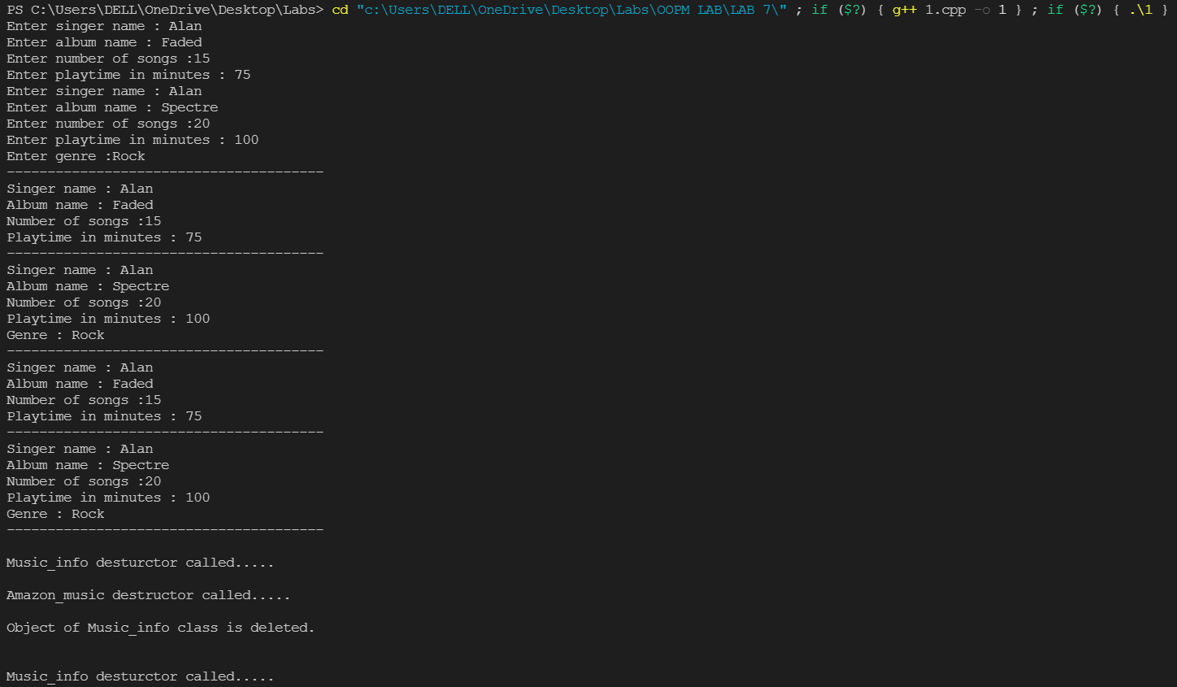

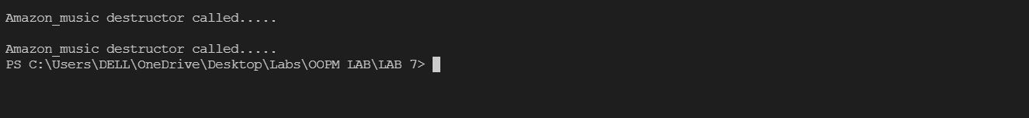

**Question2:**

**Code:**

#include<iostream>

#include<cstring>

using namespace std;

class Account_Details{

public:

string client_name;

int acc_no;

double curr_bal;

double withdraw_amount, deposit_amount;

void create(){

cout << "Enter your name : ";

cin >> client_name;

cout << "Enter your account number :";

cin >> acc_no;

cout << "Enter your current balance :";

cin >> curr_bal;

}

void deposit_money(){

double deposit_amount;

cout << "Enter amount you want to deposit : ";

cin >> deposit_amount;

curr_bal = curr_bal + deposit_amount;

cout << "Your current balance : " << curr_bal << endl;

}

void withdraw_money(){

double withdraw_amount;

cout << "Enter amount you want to withdraw : ";

cin >> withdraw_amount;

curr_bal = curr_bal - withdraw_amount;

cout << "Your current balance : " << curr_bal << endl;

}

void display(){

cout << "*************DETAILS****************\n";

cout << "Enter your name : " << client_name << endl;

cout << "Enter your account number :" << acc_no << endl;

cout << "Enter your current balance :" << curr_bal << endl;

cout << "*************************************\n";

}

};

class Regular : public Account_Details{

};

class VIP : public Account_Details{

public:

double upper_limit, interest, pending;

VIP(){

upper_limit = 500;

interest = 11.125;

}

virtual void create(){

Account_Details::create();

cout << "Enter upper-limit to loan : ";

cin >> upper_limit;

cout << "Enter simple interest to loan : ";

cin >> interest;

}

virtual void withdraw_money(){

int time;

cout << "Enter money you want to withdraw : ";

cin >> withdraw_amount;

if(curr_bal < withdraw_amount){

if(withdraw_amount - curr_bal <= upper_limit){

cout << "Enter time period to return loan : ";

cin >> time;

pending = (withdraw_amount - curr_bal) + ((withdraw_amount-curr_bal) * time * interest)/100;

}

else{

cout << "Difference amount is greater than Upper-limit exceeded";

}

}

else{

pending = 0;

}

curr_bal = curr_bal - withdraw_amount;

}

virtual void display(){

Account_Details::display();

cout << "Pending amount to pay : " << pending << endl;

}

};

int main(){

cout << "--------------Regular----------------\n";

Regular r;

r.create();

r.deposit_money();

r.withdraw_money();

r.display();

cout << "--------------------------------------\n\n";

cout << "----------------VIP-------------------\n";

VIP v;

v.create();

v.deposit_money();

v.withdraw_money();

v.display();

cout << "---------------------------------------\n\n";

return 0;

}

**Input & Output:**

